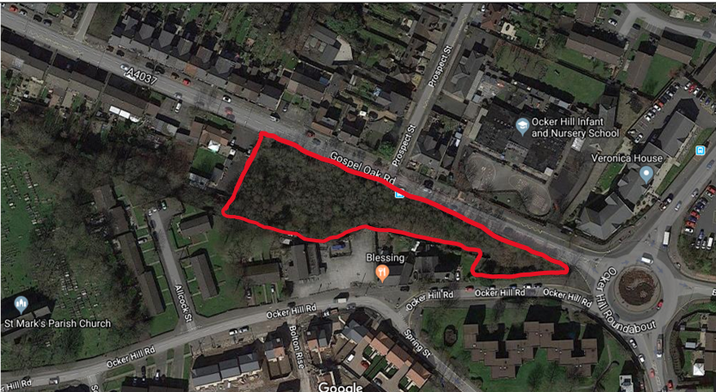

**Active Spaces Trial – Gospel Oak Road**

Sandwell Metropolitan Borough Council (SMBC) has secured funding through the West Midlands Combined Authority from Sport England to improve an area of land to provide an opportunity for local people to be more active, improve their wellbeing and potentially act as an area for education.

The area of land adjacent to Gospel Oak Road has been chosen for the Sandwell project, and stakeholder engagement is required to enable ideas about the possible future for the site to be shared.

The area is currently overgrown and a site clearance for rubbish and litter is required. However, the area offers a great opportunity acting a fresh canvas for something new.

Some examples of how the area could be utilised are:

* Forestry school sessions
* Ongoing volunteering opportunities for green maintenance
* Utilised as an area for positivity and encourage good Mental Health
* Environmental awareness and education
* Neighbourhood pocket park

Responses can be detailed on the second page

Once completed, responses can be sent to: active_spaces@sandwell.gov.uk

Any personal information will remain anonymous and responses will only used for this project.

**I think the Gospel Oak Road should include…..**